Land South of Daws Heath Rd Planning App

Rebecca Harris Facebook: rebecca4castlepoint 10/1/23
DEVELOPERS' PLANS FOR HOUSES SOUTH OF DAWS HEATH ROAD (AFFECTING WOODMANS ROUNDABOUT)
Developers are seeking views on their plans for 60 homes they want to build on Green Belt south of Daws Heath Road.
This site has not been included into any past drafts of the Castle Point Local Plan and in my view they would be trying to exploit the fact the council has withdrawn the previous draft plan if they submit this as a speculative planning application.
It is important that residents’ views are heard on this and they are fully aware of the strength of local feeling on the matter. Disappointingly, the developers, ‘Rainier’, have decided not to put up a website with details of their plans but they have put out a leaflet to some residents local to the site asking for views. The photo I have included with this post is the masterplan of what they are proposing.
They have asked that feedback on the proposals be emailed to tom.sharman@savills.com , or you can give them your feedback over the phone on 01245 293243.
A copy of the feedback I have submitted on their plans as the MP is available through this link https://www.rebeccaharris.org/south-daws-heath-road-jan-23
PLEASE GET YOUR FEEDBACK INTO THEM BY 23RD JANUARY AND PLEASE DO SPREAD THE WORD AND SHARE THIS LINK WITH ANYONE WHO YOU KNOW WOULD HAVE VIEWS ON THIS PROPOSAL!
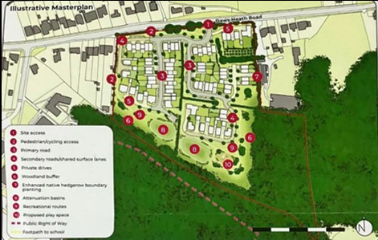

South of Daws Heath Road (Jan ’23)
Dear Rainier Developments, I was very disappointed to read your consultation for your planned development South of Daws Heath Road.
This site was not included for development in the Council’s previous draft of the Local Plan. It is therefore very clear that you are intending to exploit the fact the Council do not have a published draft of a local plan in place following the previous draft plan’s withdrawal, to deny local people a democratic say over preferred strategic development in their area. The land is designated as Green Belt and the National Planning Policy Framework clearly states, “once established, Green Belt boundaries should only be altered where exceptional circumstances are fully evidenced and justified, through the preparation or updating of plans”.
Although the Council has not had a local plan in place for some time, they are currently in the process of preparing another draft and I am sure they fully intend to adhere to Government policy while doing so. You should make the arguments you wish to make regarding the site in the emerging local plan process and let democratically elected politicians decide its suitability as a strategic site. You should not try to force the issue now with a planning application.
In September 2022 report under Section 19 of the Flood Water Management Act 2010 was released by Essex County Council, the Lead Local Flood Authority, into the flooding that occurred across the Borough on the 21st September 2021. One of the many recommendations in the report was that two key documents that form the basis of the evidence used by council planning officers regarding flood risk in Castle Point, the Local Flood Risk Management Strategy and Surface Water Management Plan (including existing hydraulic modelling), are reviewed and updated, with a particular focus on increasing risk due to climate change. Essex County Council made a public commitment at its Full Council meeting on 11th October 2022 that this recommendation will be followed and work will begin imminently. This proposal is premature, and time should be given for Castle Point Borough Council to update their planning policies to take the report and any subsequent work into account. Not only does the Section 19 report show that the flood risk evidence used by planning officers in the last draft local plan is in desperate need of revision, but the concerns it raises about the existing drainage network mean it is unlikely you will be able to accurately determine the level of investment necessary for your proposed ‘Sustainable Urban Drainage Scheme’, to ensure it will not cause unacceptable strain on existing surface water management systems in Castle Point and exacerbate flood risk for existing properties. Indeed, I also doubt whether you will be able to accurately determine whether such a scheme is even possible given the inadequacy of the wider drainage network.
The proposed development borders areas of ancient woodland on two sides. I have not seen anywhere in your promotional material any commitment to minimise the impact on the woodland and its wildlife or any indication of how you intend to achieve this, other than the inclusion of a ‘woodland buffer’, the depth of which you do not elaborate on. I am pleased you are not planning to develop the area of ancient woodland included in your site to the Southeast, but therefore I am frankly puzzled as to why you have included it within the development site zone in the first place.
Finally, regarding road transport, all vehicles entering or exiting your proposed development site via the access point onto Daws Heath Road you propose are likely to put further unacceptable congestion on the A129 Rayleigh Road around the Woodmans Arms and Rayleigh Weir junctions. Both junctions are already severely overcapacity at peak times and frequently congested throughout most of the day. Rayleigh Wier is the southern boundary of the Rayleigh Air Quality Management Area, and several concerns have been raised about the nitrogen dioxide levels in the area. Adding further congestion to Rayleigh Wier and the A129 is only going to exacerbate the problem and I cannot see any specific mitigation measures included in your proposal.
Whilst I disagree with your proposals as a whole, I fully appreciate the inclusion of a play area for recreation and your stated intention to increase biodiversity through the inclusion of features such as a wildflower meadow.
Thank you very much for consulting with local residents on your proposals and giving them the chance to express their opinion on them. I do hope you will take my comments and the comments of all the local residents who respond to this consultation on board. I urge you not to submit this application for the reasons above and to instead focus on developing smaller brownfield sites around the Borough that will provide homes for local people, without seeing the loss of undeveloped Green Belt that residents truly treasure.
Kind regards,
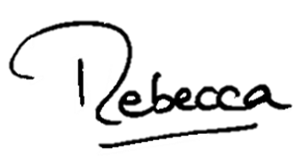Rebecca Harris Member of Parliament for Castle Point

